Preface

Trade Innovation introduces an enhanced Billing+ module. The module facilitates regular automatic billing of charges for the bank’s corporate customers. This allows any charges from or to a corporate customer in a particular period to be debited or credited periodically, rather than ad-hoc as the charges are incurred. Similarly, it allows to perform regular invoicing of charges for customers on the bank’s database and it also permits definition of billing levels for each individual customer. Other important features such as other banks' charges and participant charges are also added to this module.

The billing functionality that was previously supported as part of core Trade Innovation processing has now been incorporated in the new Billing+ module which is a standalone licensable business module. Existing Trade Innovation customers who would like to leverage the Billing+ features, should contact their Finastra representative for more information about the licence upgrade for this module.

This Guide explains how to carry out the Billing + features, using Trade Innovation's transaction processing application.

# About Periodic Billing and Invoicing

Trade Innovation permits you to perform regular, automatic billing of charges for individual customers. This allows any charges due from or payable to them in a particular period to be debited or credited periodically, rather than as they are incurred.

Similarly, you can perform regular invoicing of charges for customers on your database. The system tailoring application permits you to define for each individual customer:

* The products for which charges are to be billed or invoiced periodically
* Whether billed and invoiced charge types are combined and displayed under a single billing settlement event for a billing period
* Whether billing or invoicing is to be carried out for each transaction individually, for all transactions for each separate product individually, for all transactions for all products together, or for eligible transactions based on user defined charge grouping criteria
* Whether billing and invoicing is to be carried out by the Trade Innovation system, or whether billing and invoicing will be done via an external service and handled by a ‘Fees and Billing’ system interfaced with Trade Innovation
* The date on which billing or invoicing is to be next carried out
* The frequency thereafter with which billing or invoicing is to take place
* If the customer requires notification in advance of the charges to be billed or invoiced, the number of days notice required

For each product, you can also define the type of account to which any charges subject to periodic billing are to be booked at the point at which they are incurred.

If the Billing setup for a Billing customer consists of only Our charges billing setup, then any Participant charges or Other banks’ charges addressed to that customer will not be billed because there is no setup to include the Participant charges or/and Other banks’ charges.

See the System Tailoring User Guide – Trade Innovation for full instructions on setting up periodic billing/invoicing details.

## Billing and Invoicing via an External Service

Billing and Invoicing can be handled either by the Trade Innovation system, or ‘Externally’, where the Trade Innovation system interfaces with a ‘Fees and Billing’ system and an external service is used.

Rather than using Trade Innovation’s Billing and Invoicing functionality, where charges are processed, a Customer Billing master is created and the charge is billed or invoiced on a specific date, your bank may make use of an ‘External’ service which handles the invoicing of charges.

The external billing system may consolidate charges generated by Trade Innovation with those emanating from other systems and an invoice detailing all charges due from a particular corporate customer will be sent to the customer on a specific date.

Where charges are billed externally, Trade Innovation transmits details of each charge to the external service via the gateway. The charge is then processed by the Fees and Billing system.

## How Billed Charges are Handled by the Trade Innovation Application

Where your bank uses Trade Innovation’s billing and invoicing functionality; once periodic billing details have been entered, they come into immediate effect. During overnight processing Trade Innovation checks to see whether there are any charges for the customer that are to be taken on the next billing date. As soon as qualifying charges are detected, Trade Innovation creates a Customer Billing master record for the customer, and sets the status of the qualifying charges to 'Billed' so that they will be included in the next billing statement.

For each customer, once the next periodic billing date is reached Trade Innovation automatically generates a Billing Settlement event to debit/credit or invoice the charges for the relevant period. This takes all the charges due up to and including the date of the event with a status of 'Billed/Invoiced'.

1. You must then set the status of charges to be 'Bill/Invoice'.

The above describes the automatic handling of periodic billing. You can intervene manually in the process:

* By creating a billing master record manually, as soon as customer periodic billing details have been set up
* By creating a Billing Settlement event manually
* Using a Payment Received advice, where the customer elects to make an early payment

In addition, your bank may configure the events used to process automatic periodic billing so that they require manual intervention - such as review and authorisation - before they can be completed.

For customers who require an advice prior to their account being debited or credited, Trade Innovation generates an Advise Billing Settlement event the required number of days before the Billing Settlement event. You can use the functionality described in this chapter to take charges manually in the period after they are advised and before they are settled, if necessary.

## How Invoicing is Carried Out by the Trade Innovation Application

Where your bank uses Trade Innovation’s internal Invoicing functionality; once invoicing details have been entered, they come into immediate effect. During overnight processing Trade Innovation checks to see whether there are any charges for the customer that are to be invoiced on the next invoicing date. As soon as qualifying charges are detected, Trade Innovation creates a billing master record for the customer, and sets the status of the qualifying charges to 'Billed' so that they will be included on the next invoice.

For each customer, once the next invoicing date is reached Trade Innovation automatically generates a Billing Settlement event to invoice the charges. This event includes all charges due up to and including the date of the event with a status of 'Billed'. The event produces the actual invoice document to be sent to the recipient but no postings are made until payment has been entered.

When a payment is received, it is entered manually using a Payment Received event. The Payment Received event sets the status of the charges paid to 'Paid'.

Pre-advices and advices can be produced manually, using a Correspondence event.

You can also create a billing master record to handle invoicing for a customer manually, provided that invoicing details have already been set up for the customer. Trade Innovation will then use this billing master to identify charges to be invoiced from the next overnight processing onwards.

Your bank may configure the events used to process invoicing automatically so that they require manual intervention - such as review and authorisation - before they can be completed.

### Amending, Deleting and Booking Off Billing/Invoicing Information

During transaction processing you can exclude individual transactions from billing or invoicing; and you can override the billing level for individual transactions.

You can change periodic billing/invoicing details, including the next billing/invoicing date. Such changes come into immediate effect during the next overnight processing. You can also delete periodic billing/invoicing details, in which case they are marked by the system as obsolete, but retained for use with any outstanding charges to be billed/invoiced. The details will be deleted automatically during overnight processing when they are no longer needed.

Billing masters are booked off and subsequently deleted according to the default master retention period or the master retention period set up for the product, but only once billing/invoicing details for the customer have been deleted because regular automatic billing/invoicing is no longer required.

## How Billed/Invoiced Participant Charges are Handled by the Trade Innovation Application

Participant charges have the same billing setup structure and are handled similarly with ‘Our charges’ but they are dependent on and linked to your bank’s charges. These charges become eligible for billing or invoicing whenever the main charge (‘Our charges’) is Paid. Also billing schedules for both types of these charges are handled within the same billing setup for a given Customer resulting with a separate billing masters, one for the customer and another for each participant.

## How Billed/Invoiced Other Banks’ Charges are Handled by the Trade Innovation Application

Like Participant charges, Other banks’ charges have the same billing setup structure and can have a different Billing schedule fromother types of charges. However, Other banks’ charges only have one instance that is passed between charge payer and charge payee during Billing, unlike Our charges and Participant charges that are linked to each other. In line with the billing setup for Other banks' charges, the Billing customer is either a charge payer or a charge payee for a specific charge identified as Other bank charge at the transaction event level.

## How Combination of Charges are Handled by the Trade Innovation Application

The Combine charges feature allows your bank to combine Our charges, Participant charges and Other banks’ charges for a specific customer to be included in the same billing settlement event and thereby into a single billing advice. The default behaviour is to generate separate Billing settlement events and, therefore, a separate billing advice for each charge type.

Any combination of Charge types is permitted, i.e. all three types can be combined, or any pair can be combined. The combined Charge types must first be marked to be billed or invoiced. When only a pair are combined, the third one can still be billed or invoiced separately, or not marked for billing or invoicing.

|  |  |
| --- | --- |
| Charge types Combined | Charge types Separate/un-combined |
| None | Our, Other Banks', Participants' |
| Our, Other Banks' | Participants' |
| Our, Participants' | Other Banks' |
| Other Banks', Participants' | Our |
| Our, Other Banks', Participants' | None |

## How Charges are Handled by an External Billing Service

Where your bank uses Trade Innovation’s external billing functionality; once periodic billing details have been entered during transaction input and the event is completed, details of each charge is transmitted via a gateway.xml service message, to a Fees and Billing system interfaced with Trade Innovation.

Such charges may then be consolidated with those produced by other systems used by your bank and invoiced to corporate customers periodically.

Where charges are invoiced externally, Trade Innovation does not generate postings, settlements or netted funds movements during transaction processing and all accounting is carried out by the external Fees and Billing system.

Charges can be set to use external billing via a flag which is available in the Customer Details Billing screen in the System Tailoring application.

It is also necessary to configure your system to use the ‘Fees and Billing’, Branch Service Option, also available via System Tailoring.

## Grouping Charges for Settlement

If the billing level is set to ‘User defined’ and related charge grouping definitions are set up, any charges with status billed or invoiced, due from the customer, will be assigned to a relevant existing or new charge grouping record using the criteria defined by the corresponding charge grouping definition. A unique reference is assigned to the Billing grouping using the Billing group reference.

Billing groupings consist of a set of transaction data specified in a Billing grouping definition by means of transaction event fields. This data is used to assign billed charges into different categories for handling in Billing and also to allow the data, such as a billing account or address, to be passed from the transactions that generate the charges which become available for Billing.

When a transaction event that generates a billed charge is released, the system retrieves the data specified by the grouping definition that applies to the charge customer's billing details and uses it to assign the charge to a category based on that data. If the data is same for more than one transaction, the charges from the different transactions will be assigned to the same category.

The charge grouping is not specific to individual transactions but to any of the charges from any relevant transaction whose data in one or more event fields (declared on the related the grouping definition) matches.

For example, if one of the grouping field is the charge account, the billed charges from any transaction where a particular charge account has been selected will be assigned to that group.

If any of the data specified in a grouping definition changes on the transaction, such as by an Amend or an Adjust event, Trade Innovation will recalculate the grouping of all outstanding billed charges that have not yet become eligible for Billing.

When the Billing cycle for the Billing charge customer becomes due, the charges in the different grouping categories are assigned to separate Billing Settlement events generated, allowing them to be handled together. The data from the grouping, such as a billing charge account or charge address, can then be used in release items, such as documents.

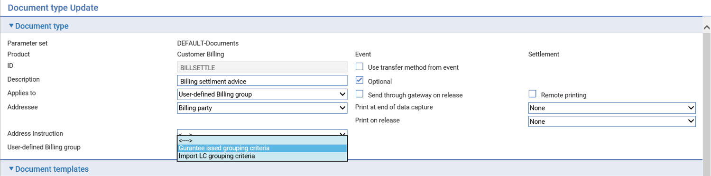

When a set of charges in the same grouping are picked up by a Billing Settlement event (for each grouping), charges can then be settled or waived in the Billing grouping that they are first assigned to or rebilled to be picked up at the next charge cycle in a new grouping corresponding to the same category that they are assigned to.

Charges remain in their grouping unless they are rebilled (when the user has amended the charge action to Bill/Invoice), in which case they are processed again in the Billing Settlements when the billing date for the customer is next reached, and they are assigned to a new grouping. This is done automatically for non-invoiced charges at the start of each new billing cycle but is only done when the user has manually edited the required charges to set their action to 'Bill' in the Billing Settlement event or the Billing Payment Received event. This means that invoiced charges remain with the grouping that they were originally assigned to, until explicitly rebilled to be transferred to a new grouping.

## The Master Summary Window

The Master Summary window for a billing master shows information on the customer and on how and when billing or invoicing is carried out for Our charges, Participant charges and Other banks’ charges.

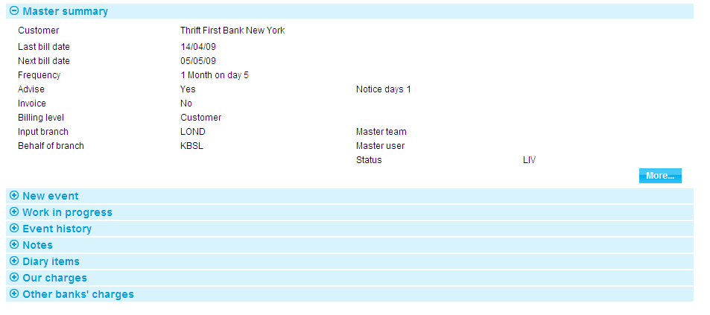

For more information on how the various panes and buttons in this window work see the Common Facilities User Guide –Trade Innovation.

## Excluding Transactions from Periodic Billing or Invoicing

During the initial event for a transaction, and during Adjust events, you can elect not to include charges for that transaction in periodic billing or invoicing. When you select the Release Items | Charges link in such an event, the Charges Summary window has a **Suppress Billing** button.

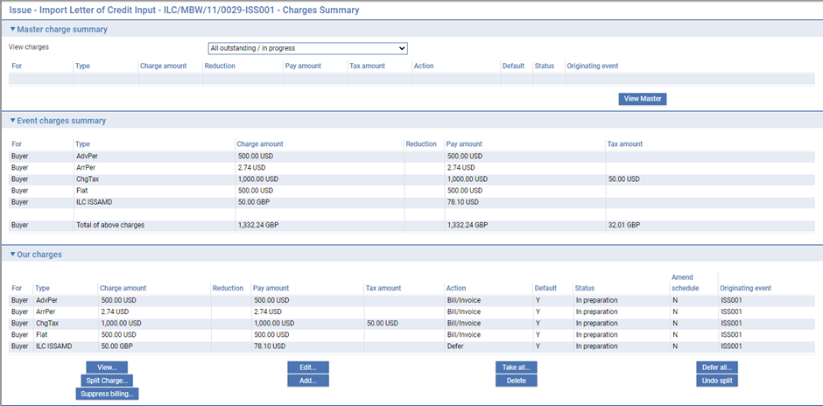

When you click this button, Trade Innovation displays a window which lists all parties to the transaction whose charges are to be billed or invoiced periodically.

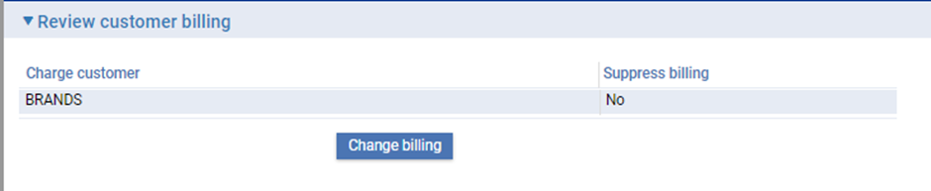

When you first open the window, the Suppress Billing column shows 'No' against each party, indicating that periodic billing or invoicing is still active for each party.

You can select each of the parties in turn and click the **Change Billing** button to suppress billing or invoicing. The Suppress Billing column for that party changes to 'Yes' and the label of the button changes to Bill when you have that party selected. You can subsequently use the **Change Billing** button to reactivate periodic billing or invoicing.

If you suppress periodic billing or invoicing in this way during an Adjust event, any charges already billed or invoiced will be unaffected, but any future charges (including charges incurred by the Adjust event itself) will not be included in periodic billing or invoicing.

## Changing the Level at which Periodic Billing or Invoicing Occurs

You can change the level at which periodic billing or invoicing occurs at transaction level. A Bill Level drop-down field (the list includes Customer, Product and Transaction but excludes User defined) is present within the events used to create a new transaction, which can be used to set a different billing or invoicing level for that transaction only.

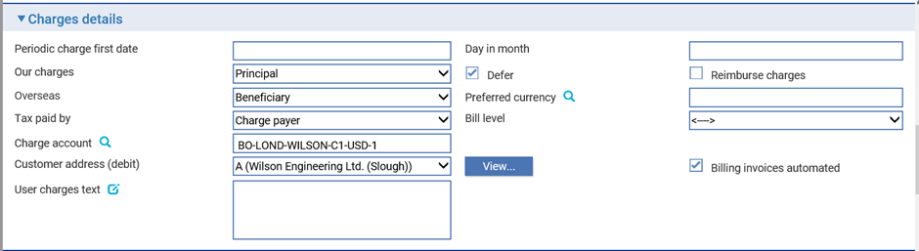

See the product-specific user guides for information on where this field appears for individual products.

## Using Trade Innovation to Process Periodic Billing and Invoicing

The table below lists the events covered in this Guide, explaining what each event allows you to do. The table lists the names given to events when Trade Innovation is delivered. Your bank can change these names once the system is installed. Consequently, the names in your version of Trade Innovation may be different from the ones listed here.

There are two names for each event:

* The full name, which is displayed when you choose a new event
* The short name, which is displayed in the Work in Progress pane of the Master Summary window

This Guide uses the full name of each event, as delivered with the system.

In addition to the events listed in the table, you can also use the functionality described in the Common Facilities User Guide – Trade Innovation when processing transactions in Trade Innovation.

|  |  |  |
| --- | --- | --- |
| Full Name | Short Name | What it Does |
| Advise | Advise Billing Settlement | Allows you to process a notification of billing or invoicing (see page 9). |
| Amend | Amend Customer Billing | Allows you to amend billing master record details (see page 25). |
| Create | Create | Allows you to create a billing master record manually (see page 24). |
| Pay Rec’d | Payment Received | Allows you to record payment against invoiced charges (see page 14). |
| Settlement | Billing Settlement | Allows you to create or complete a Billing Settlement event (to collect charges) manually (see page 13). |

# Billing and Invoice Notification Advices

This chapter covers the production of billing and invoice notifications when using Trade Innovation’s Billing and Invoicing functionality.

1. It does not apply to charges billed via an External Billing Service.

## Billing/Invoice Notification Advices

Notification advices are produced by the Advise Billing Settlement event, which is generated during overnight processing.

The Advise Billing Settlement event shows the customer's short name, the date on which the event was produced, and the period covered by the billing statement or invoice.

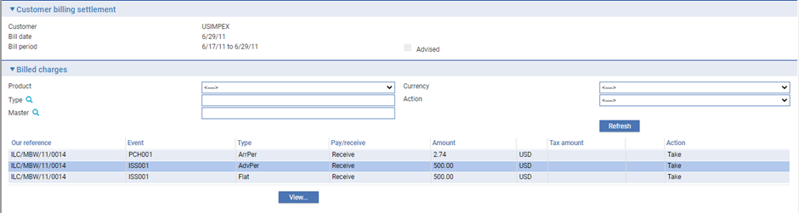

When Charge types have been combined, a single Advise Billing Settlement event will be generated for the combined Charge types. Where a Charge type is not combined, it will be in a separate Advise Billing Settlement event.

The Billed Charges pane lists each of the charges to be included on the billing statement or invoice, showing information for each under the following headings:

|  |  |
| --- | --- |
| Heading | What it Shows |
| Our Reference | Your bank's reference for the transaction in which the charge was raised. |
| Event | The reference of the event in which the charge was raised. |
| Type | The type of charge. |
| Pay/Receive | Indicates whether the charge is one that your bank will receive, or one that it is to pay to a correspondent bank or a participant. |
| Amount | The charge amount and currency. |
| Tax Amount | If relevant the amount due in tax for the charge, and currency. |
| Action | The charge action. By default, this is set to 'Take'. |

You can use the **View** button to view details of individual charges.

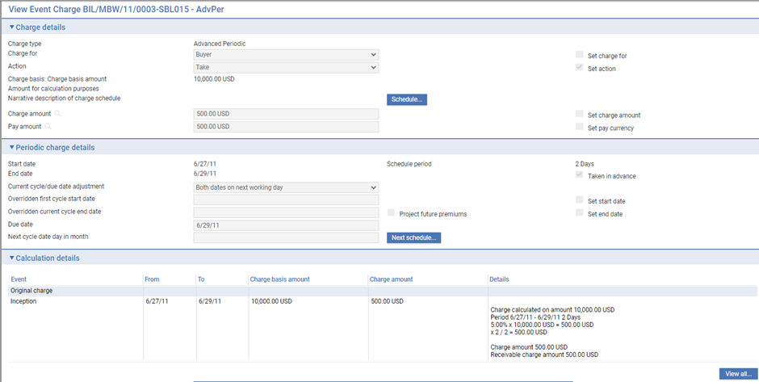

You can also amend the charge using the **Edit** button. In the window that is displayed you can amend the charge amount and currency, the charge action, and who the charge is for. If you change the charge action from 'Take' to 'Bill/Invoice', the charges are postponed until the next billing advice or invoice is produced for that customer. You can also waive charges by selecting 'Waive' in the Action field.

Clicking the **Bill All** button postpones all the charges listed until the next billing advice or invoice is produced for that customer.

# Settling Billed Charges

This chapter explains how billed charges are settled when using Trade Innovation’s Billing and Invoicing functionality.

Note that it does not apply to charges billed via an External Billing Service.

It covers automatic settlement, and settlement using a manually entered Billing Settlement event.

## Overview

Settlement itself is handled using a Billing Settlement event, which is generated automatically either during overnight processing on the required date; or created as a diary action when the related Advise Billing Settlement event has been released.

An automatically generated Billing Settlement event picks up eligible billable charges according to the billing level (Customer, Product, Transaction or User defined) set for the customer. The user defined level based on charge grouping definition enables the bank to set up more complex billing selection criteria for eligible charges based on the applicable charge billing grouping criteria, leading to generation of a Billing Settlement event per applied grouping criteria. This allows the bank to produce billing advice/invoice for a given customer per subsidiary based on the details such as customer address, charge account etc. New charges related to event fields are introduced at the product level to increase the scope of user defined charge grouping criteria.

See the product-specific user guides for information.

A manual Billing Settlement event can be used if an automatic Billing Settlement event fails through lack of funds, to allow you to collect the outstanding charges, or in circumstances where a one-off invoice is needed.

1. You can create a Billing Settlement event only if there are billed or invoiced charges to be collected against the billing master record. A manual Billing Settlement event will only collect billable charges. Other charges will need to be collected using a Maintain Charges event.

For periodic billing, upon release of the event, the system generates the necessary posting entries and payment messages to receive or pay charges and sets the status of those charges as 'Paid'.

For invoicing, no postings are generated upon release of the event; and the status of charges remains 'Invoiced' until a Payment Received event is used to allocate funds to them.

The same functionality is used to view automatically generated Billing Settlement events and Billing Settlement events created manually (see page 13).

## Automatic Settlement

An automatically generated Billing Settlement event shows the customer's short name, the date on which the event was produced, and the period covered by the billing statement or invoice. The Advised flag is checked if the customer has been advised in advance of the charges using an Advise Billing Settlement event.



When Charge types have been combined, a single Billing Settlement event will be generated for the combined Charge types. Where a Charge type is not combined, it will be in a separate Billing Settlement event.

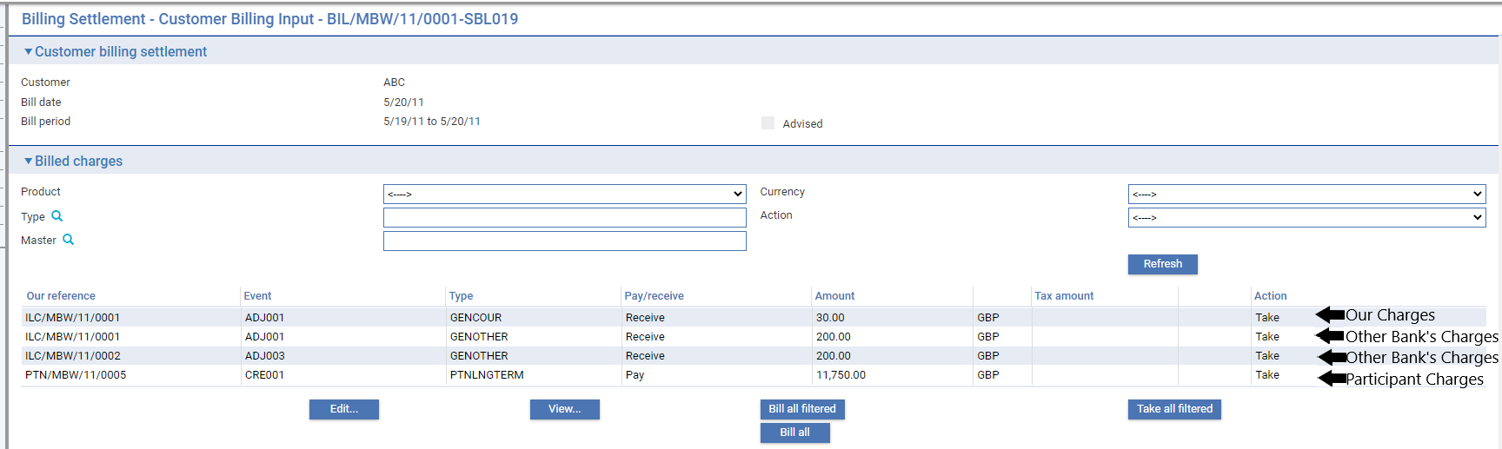

The Billed Charges pane lists each of the charges to be included on the billing statement or invoice, showing information for each under the following headings:

|  |  |
| --- | --- |
| Heading | What it Shows |
| Our Reference | Your bank's reference for the transaction in which the charge was raised. |
| Event | The reference of the event in which the charge was raised. |
| Type | The type of charge. |
| Pay/Receive | Indicates whether the charge is one that your bank will receive, or one that it is to pay to a correspondent bank or a participant. |
| Amount | The charge amount and currency. |
| Tax Amount | If relevant the amount due in tax for the charge, and currency. |
| Action | The charge action. By default, this is set to 'Take'. |

You can use the **View** button to view details of individual charges.



You can also amend the charge using the **Edit** button. In the window that is displayed you can amend the charge amount and currency, the charge action, and who the charge is for. If you change the charge action from 'Take' to 'Bill/Invoice', the charges are postponed until the next billing advice or invoice is produced for that customer. You can also waive charges by selecting 'Waive' in the Action field.

Clicking the **Bill All** button postpones all the charges listed until the next billing advice or invoice is produced for that customer.

## Creating a Billing Settlement Event Manually

To create a Billing Settlement event manually, with the billing master open in the Master Summary window select 'Billing Settlement' from the Create New Event drop-down list. Trade Innovation opens the event at either a Log step or Input step. Depending on how your system is configured, panes and fields available in log steps can be tailored for each data capture step. See the *SDK - Systems Interfacing Guide* – Trade Innovation for details.

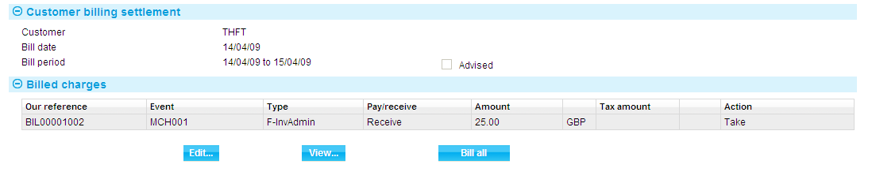

You can use the **View** button to view details of individual charges.

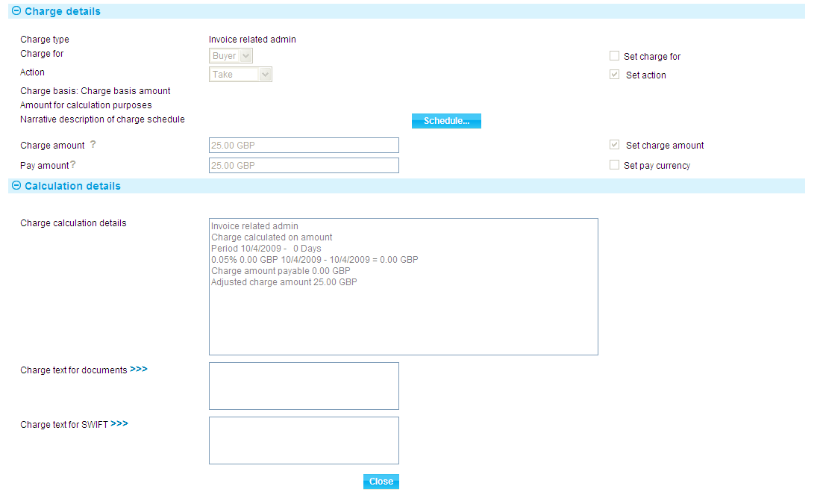

You can also amend the charge using the **Edit** button. In the window that is displayed you can amend the charge amount and currency, the charge action, and who the charge is for. If you change the charge action from 'Take' to 'Bill/Invoice', the charges are postponed until the next billing advice or invoice is produced for that customer. You can also waive charges by selecting 'Waive' in the Action field.

You can use the **Bill All** button to postpone all the charges listed.

# Recording Payment against Invoiced Charges

This chapter explains how to record payment against invoiced charges.

1. It does not apply to charges billed via an External Billing Service.

## Recording Payment

Once released, a Billing Settlement event for invoicing is held with the status of 'Await Pay' until payment is received and recorded against it. When payment is received, details of the charges being paid are entered against the relevant invoice using a Payment Received event. This event permits you to record which individual charges are covered by the payment. Since these may occur on separate invoices, the event permits you to access events which still have charges outstanding and allocate the payment to individual charges held on them. Once an invoice is paid in full, its status changes to 'Paid'.

When a payment is received, you can use it to pay only those charges outstanding that are in the same currency as the payment amount.

The Outstanding Invoices report permits you to list all invoices with outstanding charges on them, as described in the Trade Innovation Reports manual.

In the Master Summary window select 'Payment Received' from the Create New Event drop-down list and click Create. Trade Innovation opens the event at either a Log step or Input step. Depending on how your system is configured, panes and fields available in log steps can be tailored for each data capture step. See the *SDK - Systems Interfacing Guide* –Trade Innovation for details.

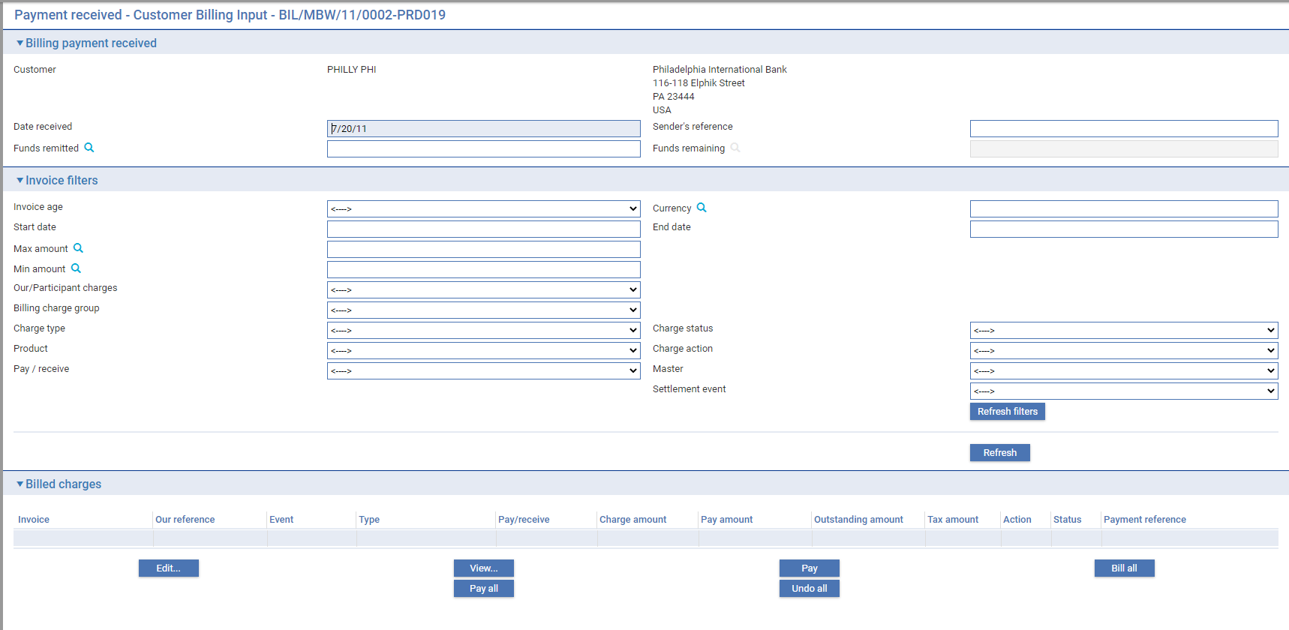

The window can be used to list all the charges in all the Billing Settlement events for the customer that has not been fully paid.

You can limit what is displayed to charges for invoices raised during a certain period in the past relative to the current business day by selecting from the options in the Invoice Age field. The remainder of the fields in the Invoice Filters pane allows you to limit the display to:

* Invoices raised during a particular period
* Charges in a particular currency
* Charges that fall within a range of amounts
* Chose to filter and work on either Our charges or Participant charges
* Charges with specific billing charge group
* Charges of a particular type
* Charges at a particular status
* Charges arising out of a specific product
* Charges with specific charge action
* Charges whether pay or receive from perspective of ourselves
* Charges arising out a specific master transaction
* Charges handled by a specific settlement event



* Charges with specific grouping reference
* Charges with specific setting of ‘Billing invoices automated’ (yes or No)
* Charges with specific charge account
* Charges with specific charge currency

Set the relevant filters and click the **Refresh** button to display the required list of billed charges.

1. To avoid unnecessary delay for the user, this list is not automatically refreshed.

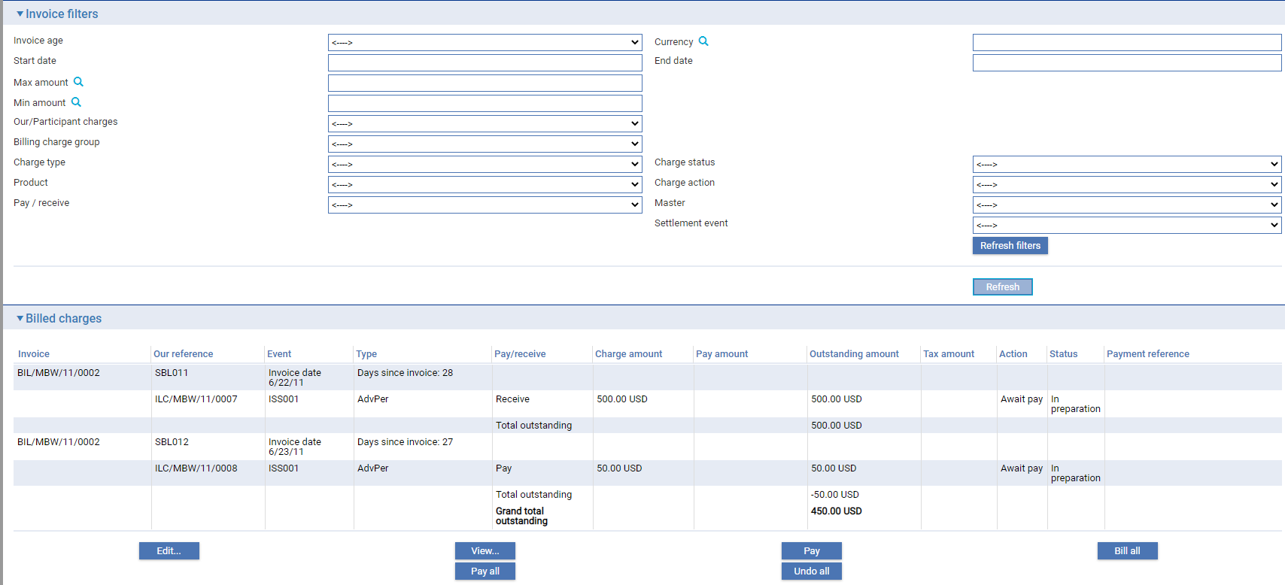

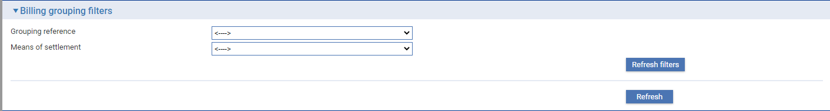

Information is shown for each charge under the following headings:

|  |  |
| --- | --- |
| Heading | What it Shows |
| Invoice | The reference of the Billing Settlement event in which the charges were invoiced. |
| Our Reference | Your bank's reference for the transaction in which the charge was raised. |
| Event | The reference of the event in which the charge was raised. |
| Type | The type of charge. |
| Pay/Receive | Indicates whether the charge is one that your bank will receive, or one that it is to pay to a correspondent bank or a participant. |
| Charge Amount | The charge amount and currency. |
| Pay Amount | The amount of charge paid in this event |
| Outstanding Amount | The amount of charge remain outstanding in this event. |
| Tax Amount | If relevant the amount due in tax for the charge, and currency. |
| Action | The action applied to the charge in this event. |
| Status | The charge status. For charge that has been paid (partially or fully), status , includes the reference of the Payment Received event where it was paid. |
| Payment Reference | The reference of an event where the charge was last paid. |

You can use the **View** button to view details of individual charges.

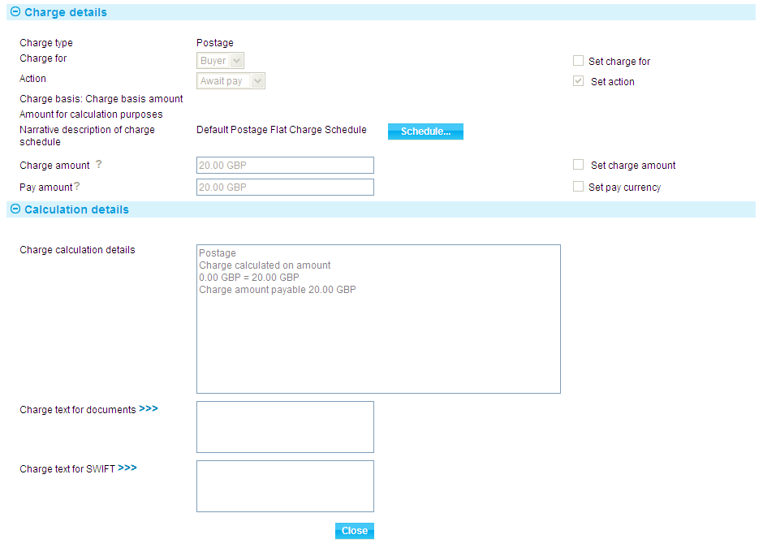

You can also amend the charge using the **Edit** button. In the window that is displayed you can amend the charge amount and currency, the charge action, and who the charge is for. If you change the charge action from 'Take' to 'Bill/Invoice', the charges are postponed until the next billing advice or invoice is produced for that customer. You can also waive charges by selecting 'Waive' in the Action field.

Enter the date the payment was received into the Date Received field, the sender's reference for the payment (if one was provided) into the Sender's Reference field, and the amount of the payment in the Funds Remitted field.

1. To flag a particular charge as paid, select it, and then click the **Pay** button. To flag all the charges displayed as paid, click the **Pay All** button. The status of the paid charges is changed 'Take'.

Note that you can only select for payment charges that are in the same currency as the payment amount, and which have a status of Await Pay.

To defer payment of all unpaid charges until the next invoicing period, click the **Bill All** button.

The **Undo All** button resets the status of all the charges to what is was when the event was first opened.

When you save the Payment Received event, Trade Innovation reconciles the total of charges paid with the amount received. Warning messages are produced if the amounts or currency differ and any remaining, unallocated amount is displayed in the Funds Remaining field.

Once the Payment Received event has been released, the status of those Billing Settlement events for which all charges have now been paid is changed to 'Paid'.

In case of participant charges or other banks’ charges are selected, an extra column is displayed, ‘Related charge’.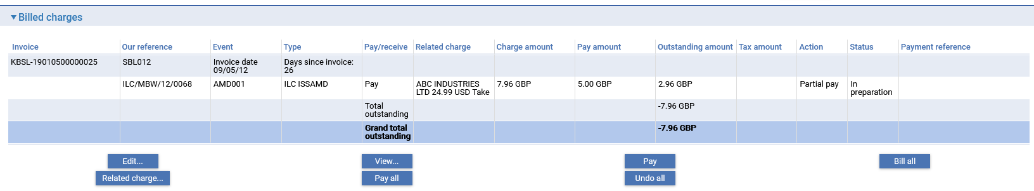

|  |  |
| --- | --- |
| Field | Description |
| Related charge | Shows the charge party, amount, and last action taken |

Use the **Related charge…** button to view the details of the selected charge and its related charge

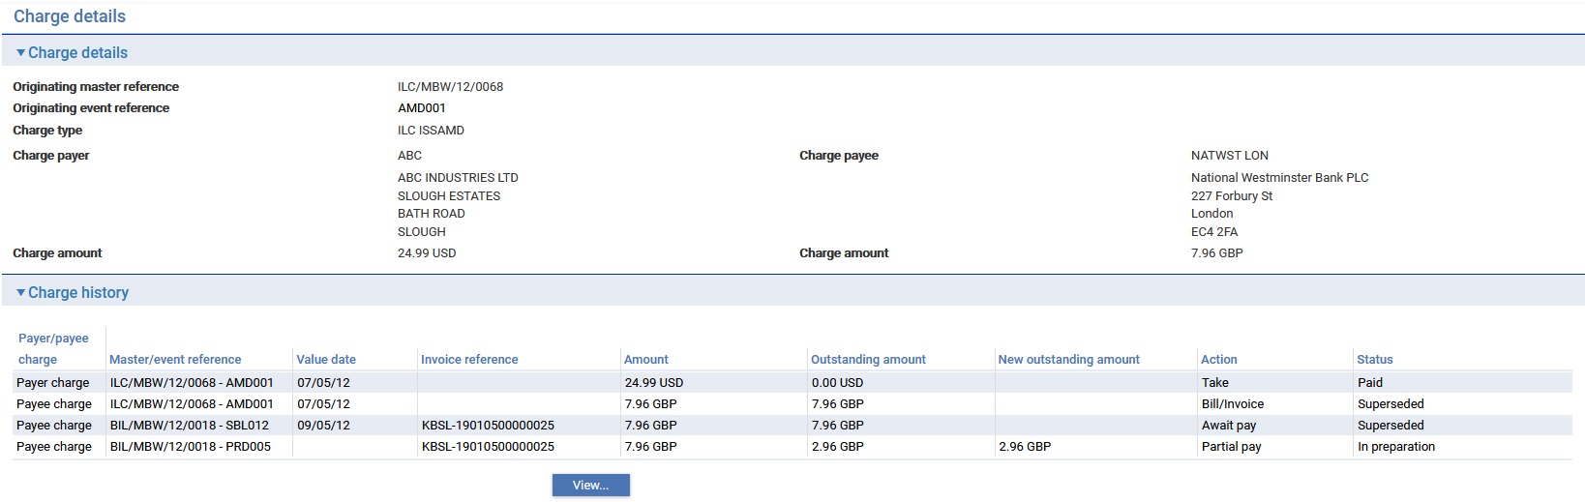

Use the **View…** button to display more details the master and event where that charge was processed

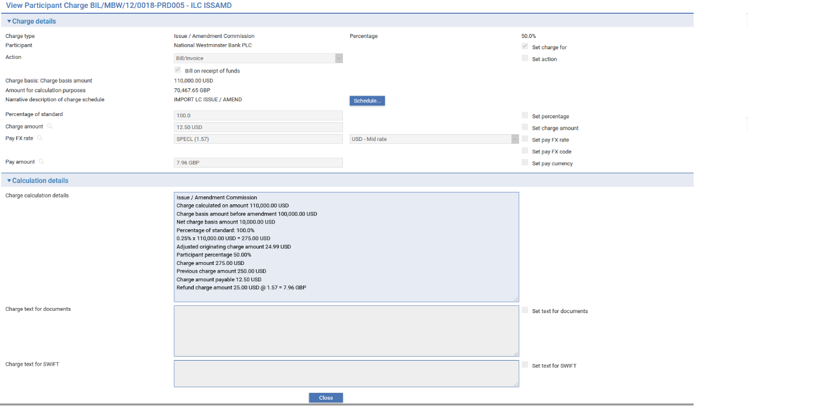

# Partial Payment

A BillingPayment Received event can be used to partially pay billed one-off or periodic charges.

It is also possible to partially waive billed one-off or periodic charges. For an example, when the customer disputes the full charge amount and an agreement is reached to take payment of a lower amount. In this case, the charge amount to be collected is partially paid and the remaining amount is waived. The action for the remaining amount can also be set to ‘Bill/Invoice’ and the charge will be reflected in the next billing settlement event for the next period.

## Partial Payment of Our Charges

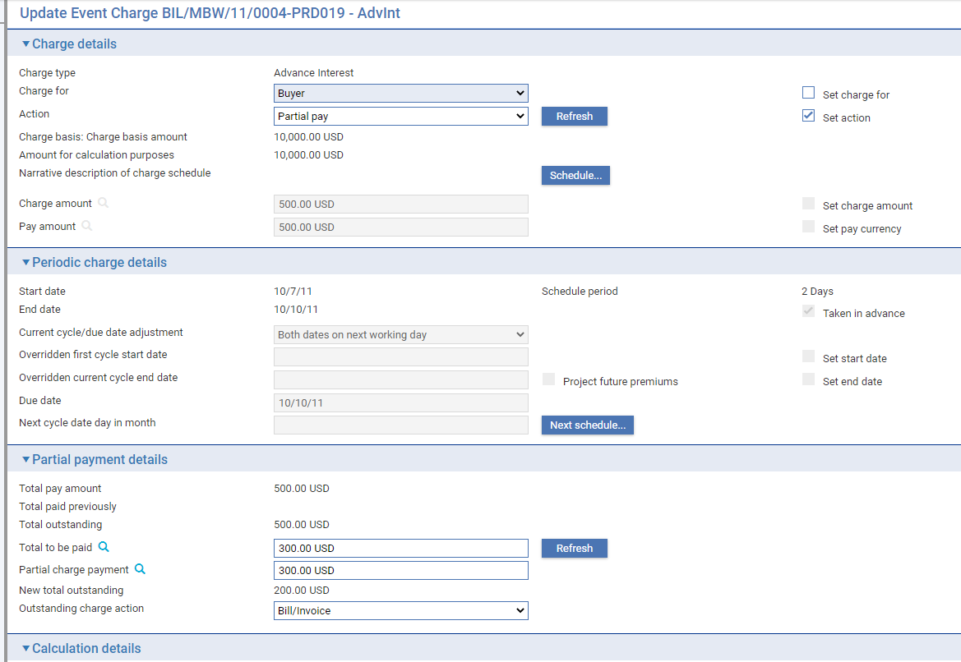

## Partial Payment of Participant Charges

As participants receive a part of the bank’s participated charge, partial payments have the same behaviour, billing participant charges are paid based on the pro-rata amount paid on the main/related charge. The participant charge can be billed at the next billing cycle once the related charge is paid or waived. In the case of partial payment, the participant charge is billed with the same pro-rata amount.

The participant bank receives a share of a given main charge when it has been collected by the lead bank from their customer.

A partial payment can be processed on a main billed charge, then the participant’s related charge be partially paid on the next billing cycle.

## Partial Payment of Other Banks’ Charges

For Other banks’ charges, billed partial payments between charge payer and charge payee have the same amount.

If the charge payer is billed first during payment of Other banks’ charge, there are options to bill the charge payee after the Other banks’ charge is fully paid or partially paid by charge payer

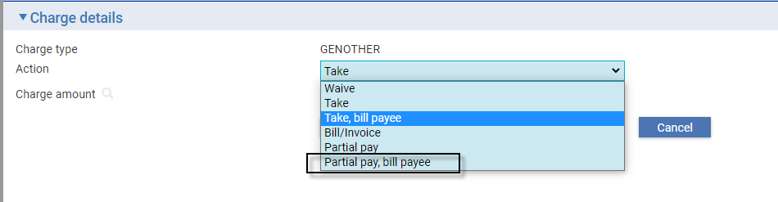

|  |  |
| --- | --- |
| Action | Description |
| Partial pay, bill payee | Partially receive the charge from the charge payer, then bill the same amount to the charge payee |

If the charge payee is billed first during payment of Other banks’ charge, there are options to bill the charge payer after the Other banks’ charge is fully paid or partially paid to the charge payee.

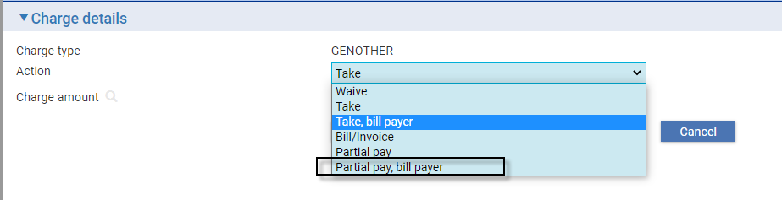

|  |  |
| --- | --- |
| Action | Description |
| Partial pay, bill payer | Partially pay the charge to the charge payee, then bill the same amount to the charge payer |

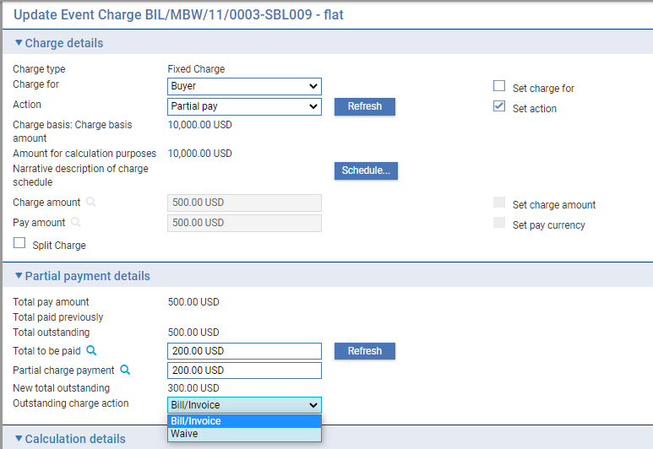

A warning is given in manual Billing Settlement event or Payment Received event, if the Participant’s charge payment exceeds the expected amount based on the partial amount had been collected on the main charge.

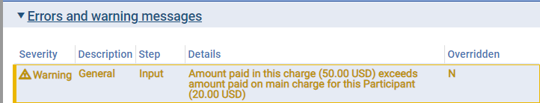

# Bill on Receipt of Funds

## Participant Charges

When processing a transaction with Billed Participant charges, in Release items | Charges | Participant charge, Billed or Invoiced charges have the flag ‘Bill on receipt of funds’.

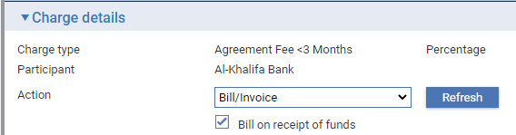

This checkbox is only available when the charge action of the Participant charge to which it applies is 'Bill/Invoice'.

If it is set, the system checks the action recorded on the main charge which is being shared and, if this charge is not being taken (and paid), it will set the charge billing status of the Participant charge to 'F' ("Awaiting receipt of funds"). This ensures that it is not picked up by End of Day Billing Settlements until the main charge has been paid. This may be outside of Billing or after the main charge has been transferred to Billing then either paid immediately in the Billing Settlement step (if not invoiced) or else paid in the Payment Received event (if invoiced).

The system automatically updates the charge billing status to 'B' ("Billed") of any Participant charges with which it is shared, and which are only paid on receipt of funds. Participant billing charge can also be Billed if the main charge is waived. This makes the Participant charges eligible to be transferred to billing at the next billing cycle specified in the Participant Billing details. If the flag is unchecked, the participant charge can be billed and/or settled regardless of the status from the main charge.

|  |  |  |
| --- | --- | --- |
| Related Charge Last Action | Bill on receipt of funds | Participant charge Status on Next Billing date |
| Take | Y | **Billed/Invoiced** |
| Bill/Invoice | Y | **Awaiting receipt of funds** |
| Bill/Invoice | N | **Billed/Invoiced** |
| Waive | Y | **Billed/Invoiced** |

The default value of the flag ‘Bill on receipt of funds’ in the Participant charge details is being set from the Branch Trade Finance system option ‘PartpnChgsDefaultPriorPay’ for each required Main Banking Entity. The system option will only be setting the default value that still can be overridden by the user by updating the ‘Bill on receipt of funds’ flag.

## Other Banks’ Charges

When processing a transaction with billed Other banks’ charges, in Release items | Charges | Other banks’ charges, the Other banks’ charge details includes a flag, “Bill on receipt of funds”. 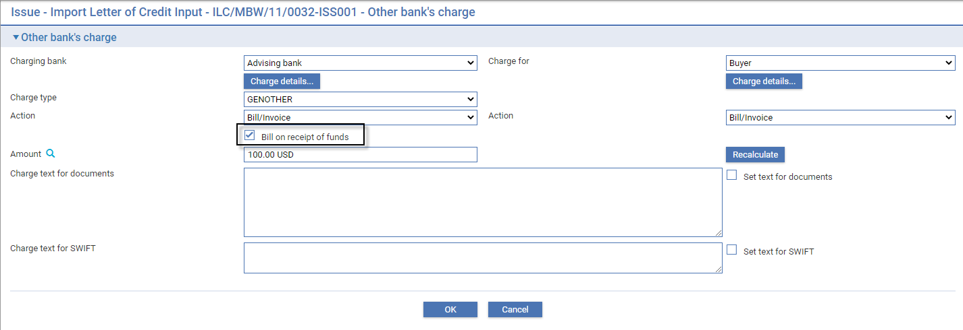

This flag is available only when the action of the Other banks’ charge by the Charging bank and Charge for party is 'Bill/Invoice'.

Since Other banks’ charges only consist of one instance of the charge unlike Participant charges that have a related charge (Our charge), the Other banks’ charge is shared between the charge payee and charge payer. This is the current behavior of Trade Innovation and the Billing process works with the single instance of the Other banks’ charge meaning that it cannot be processed simultaneously on both Billing parties.

If the flag is set, the system checks if the charge payer has already paid. This ensures that it is not picked up by End of Day Billing Settlements until the charge payer has paid. This may be outside of Billing or after the charge payer has paid through Billing Settlement event (if not invoiced) or in the Payment Received event (if invoiced).

If the flag is not set, the system checks the next billing dates of both parties. The Other bank’s charge is billed first for the party whose billing date is earlier. If both parties have the same billing dates, the Other banks’ charge is billed first to the charge payer.

The system automatically updates the charge billing status to 'B' ("Billed") of any Other banks’ charges which are only paid on receipt of funds. Other banks’ billing charges can also be Billed if the related charge is waived. This makes the Other banks’ charges eligible to be transferred to billing at the next billing cycle specified in the Other banks’ charges Billing details.

The default value of the flag ‘Bill on receipt of funds’ in the Other banks’ charge details is being set from the Branch Trade Finance system option ‘OtherBankChgsDefaultPriorPay’ for each required Main Banking Entity. The system option sets the default value on Other banks’ charges that can be overridden by the user by updating the ‘Bill on receipt of funds’ flag. The table below shows who is billed first given that both parties have ‘Bill/Invoice’ action for the Other banks’ charge.

|  |  |  |
| --- | --- | --- |
| Bill on receipt of funds | Earlier Next Billing date | First Billed party |
| **Y** | Charging bank | Charge for party |
| **Y** | Charge for party | Charge for party |
| **Y** | Same Billing date | Charge for party |
| **N** | Charging bank | Charging bank |
| **N** | Charge for party | Charge for party |
| **N** | Same Billing date | Charge for party |

# Creating a Billing Master Manually

This chapter explains how to create a billing master record manually.

1. It does not apply to charges billed via an External Billing Service.

## Billing Charges Manually

Trade Innovation allows you to create a billing master manually. You may wish to do this if, for example, you have set up periodic billing or invoicing for a customer with whom you end your business relationship before the first billing or invoicing date is reached. In such a case, you would need to create a billing master, then enter a Billing Settlement event against it manually (see page 13) to collect all charges eligible for billing or invoicing due up to and including the date of the event.

You can also collect outstanding charges eligible for billing or invoicing by changing the next billing date for the customer to today's processing date. The charges will then be handled in the usual way as during overnight processing.

## Creating a Billing Master Manually

To create a billing master manually, in the Masters window, select the Team and Behalf of branch and use the drop-down list in the New Masters pane to select 'Customer Billing', then click New. Trade Innovation creates a Create event at either a Log step or Input step. Depending on how your system is configured, panes and fields available in log steps can be tailored for each data capture step. See the *SDK - Systems Interfacing Guide* –Trade Innovation for details.

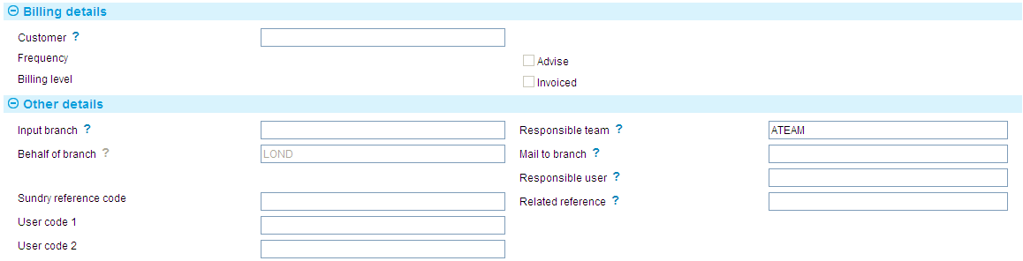

Use the Customer field to select the customer for whom you want to create a new billing master. Trade Innovation lists only those customers for whom periodic billing or invoicing details have been set up and for whom a billing master has not already been created. Once you have selected the customer, Trade Innovation displays information on the billing/invoicing frequency and notification requirement for that customer.

Trade Innovation also retrieves the input branch for that customer - and the behalf of branch, the mail to branch and team too, if they have been defined - and displays the information in the appropriate fields, where you can amend it, if required.

You may use the User Code fields to enter a value for analysis purposes. Your bank will have devised its own system for using this field.

The billing master proceeds to completion in the normal way. Once it has been released, Trade Innovation uses it to bill or invoice charges in the usual way.

# Amending a Billing Master Record

This chapter explains how to amend a billing master record.

1. It does not apply to charges billed via an External Billing Service.

## Amending a Billing Master's Details

To amend an export letter of credit, in the Master Summary window select 'Amend Customer Billing' from the Create New Event drop-down list and click Create. Trade Innovation opens the event at either a Log step or Input step. Depending on how your system is configured, panes and fields available in log steps can be tailored for each data capture step. See the *SDK - Systems Interfacing Guide* – Trade Innovation for details.



The Billing Details pane shows:

* The frequency of billing/invoicing
* Whether an advice is required and, if so, the notice period
* The billing level

For invoicing, whether any current charges have been invoiced.

The following table explains what to enter into the fields in the Other Details pane. The values displayed here are taken from the customer's details:

| Field | What to Enter |
| --- | --- |
| Input Branch | The input branch for the transaction. The input branch is set from either :   * the accounting branch from the user’s team, or * the transaction branch for user if the user has a default transaction branch or is locked to a specific branch, or * a branch associated with the user where the user can enter transactions for several branches for a team |
| Responsible Team | The team that has overall responsibility for the master e.g. as the contact to resolve any queries or issues regarding the master and associated events. Trade Innovation defaults the responsible team when creating the transaction as follows:   * Manual – set from team creating the transaction * Gateway – set from the team specified on the incoming message (if present and valid) otherwise to the team to which the transaction is assigned through workflow allocation based on the behalf of branch * SWIFT – set to the team to which the transaction is assigned through workflow allocation based on the behalf of branch   It can be changed, if required, to either the team associated with the primary customer, default team for the product or the user’s current team. |
| Behalf Of Branch | The behalf of branch for the transaction as entered by the user or set from the incoming SWIFT or gateway message. The behalf of branch determines the parameter sets that are to be used to generate charges, documents, postings, etc. during transaction processing. The branch can be changed to any other branch within the same main banking entity that shares the same parameter sets. |
| Mail To Branch | The mail to branch can be set to any branch within the main banking entity of the behalf of branch. |
| User Codes | You may use these three fields to enter user codes for analysis purposes. Your bank will have devised its own system for using these fields. |
| Related Reference | If the billing master is associated with an existing transaction, enter the reference number of the associated transaction here. |

# Using an External Fees and Billing Service

For charges that are to be billed to customers via an external Fees and Billing system, it’s necessary to configure your system to generate the charge so that:

* The Fees and Billing service is mapped to branches that will use it
* Your customer is set up to use external billing
* A message is transmitted to the fees and billing system with full details of the charge, such as:
* the customer mnemonic
* the amount
* the charge type
* the Trade Innovation transaction reference
* the transaction date
* Postings are not generated
* Settlements are not generated
* You are notified during transaction processing that the charge is billed externally

The charge, when received by the external billing system may then be consolidated with charges emanating from other systems used by your bank and invoiced to your customer, at agreed intervals.

## Setting Charges to Bill Externally

In System Tailoring, ensure that the Fees and Billing Service is assigned to a branch.

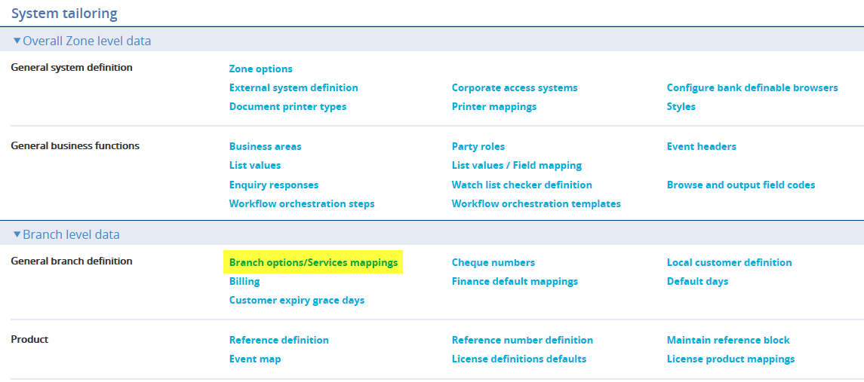

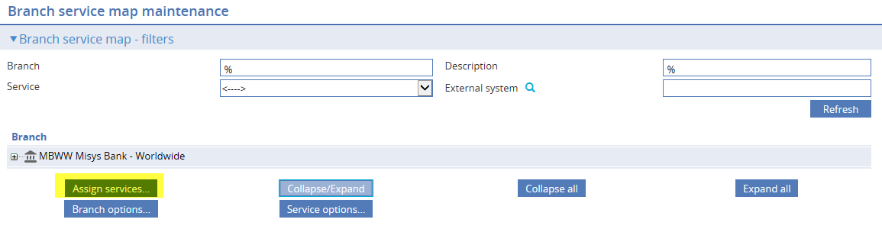

Select the ‘Fees and Billing’ service from the dropdown list. Clicking **OK** assigns the service to the branch.

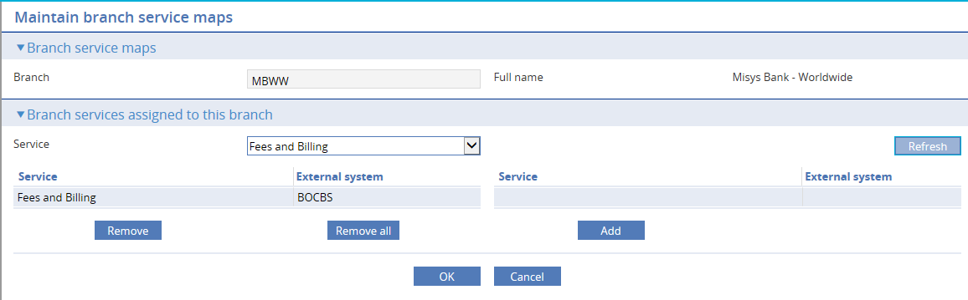

## Setting Customers to Use External Billing

Where your bank’s customers have arranged that their transaction charges will be invoiced and are to be consolidated with those generated by non-trade finance related transactions, set the following flag on the billing details for each customer that will use the external service.

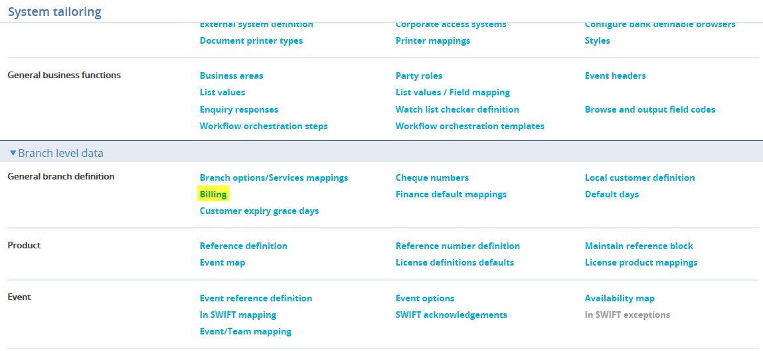

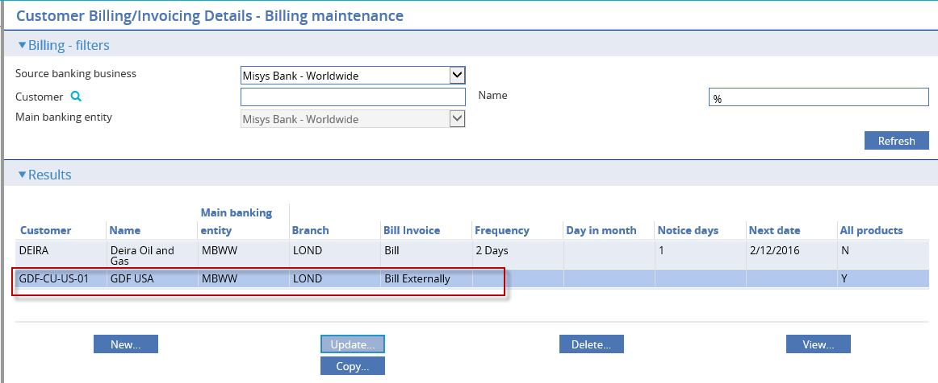

Check the Use external billing flag. All billed charges for the customer will use the external service.

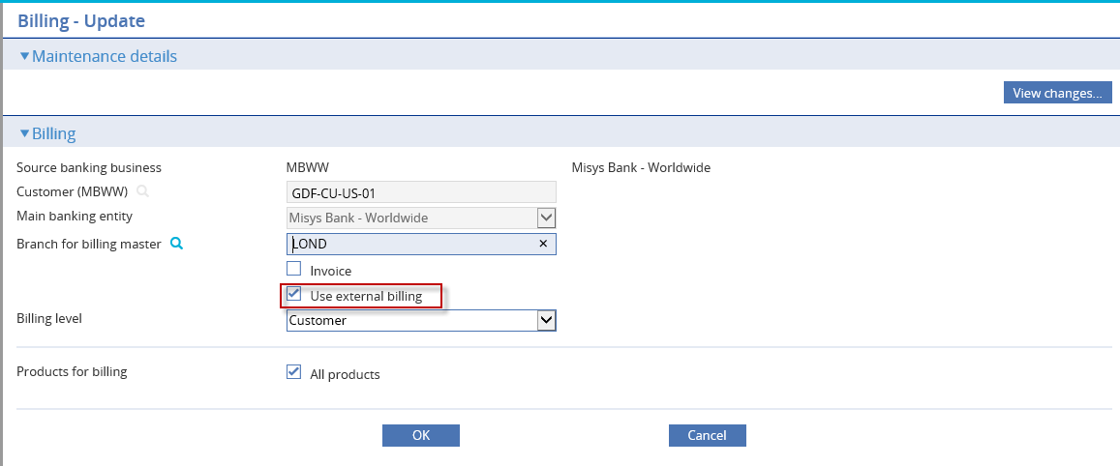

## Charge Types

To ensure that charges generated by transactions in Trade Innovation are processed by the external service, it’s necessary to replicate all ’Charge types’ defined in Trade Innovation with those in the external Fees and Billing system, so that when charges are received, the charge type is identified, and the fee may then be processed.

Note that postings and settlements are not generated by Trade Innovation for externally billed charges, so it is important to ensure that charge types match with those defined in the Fees and Billing system which handles accounting and collection of charges.

## Charge Refunds

If it’s necessary to refund a charge, this is possible via the Maintain charge event. An ‘Update’ message may be transmitted to the Fees and Billing system advising the transaction details which include the amount of the refund.

## End of Day Processing

Externally billed charges are not included in, or processed during End of Day, Batch processing.

As a customer billing master record does not get created where a customer is set to use external billing, during end of day processing, billing settlement events are not generated.

## User-defined Warning

Your bank may create a User defined warning, via System Tailoring if required, in order to notify you, during transaction processing, that a charge is to be billed externally. For example:

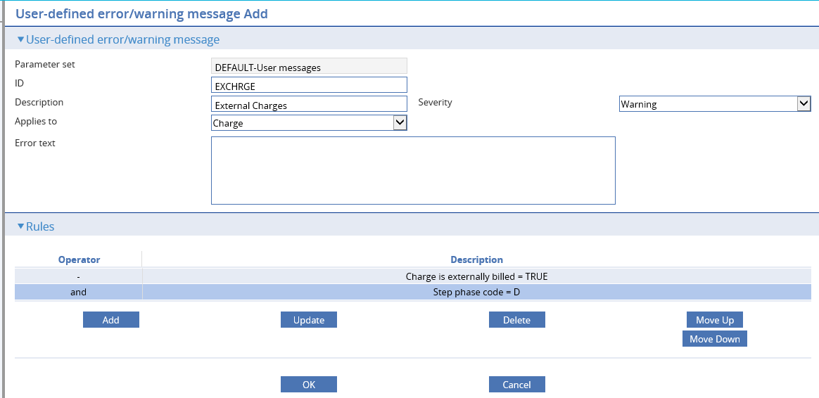

During transaction processing, the following warning is generated:

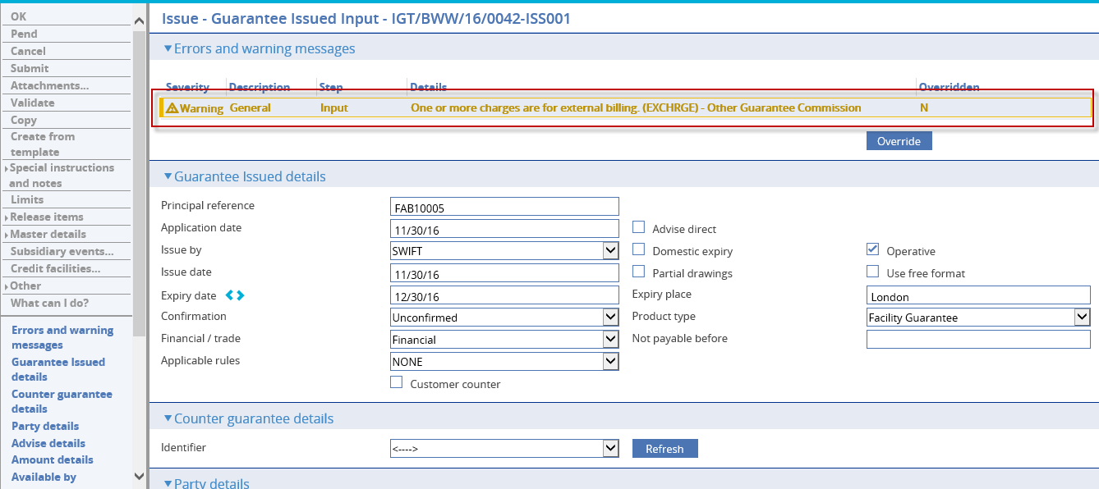

See the following documents for further details on setting up external billing functionality:

System Tailoring User Guide – Trade Innovation

*Fees and Billing Interface Guide – TIFAB Interface*